Class Diagrams

The class diagrams below do not contain attributes or methods for clarity’s sake. A full description of the class can be found in the package diagram or the data dictionary.

1. Classe diagram showing the classes involved in bookings, flights, fleet (planes) and services.

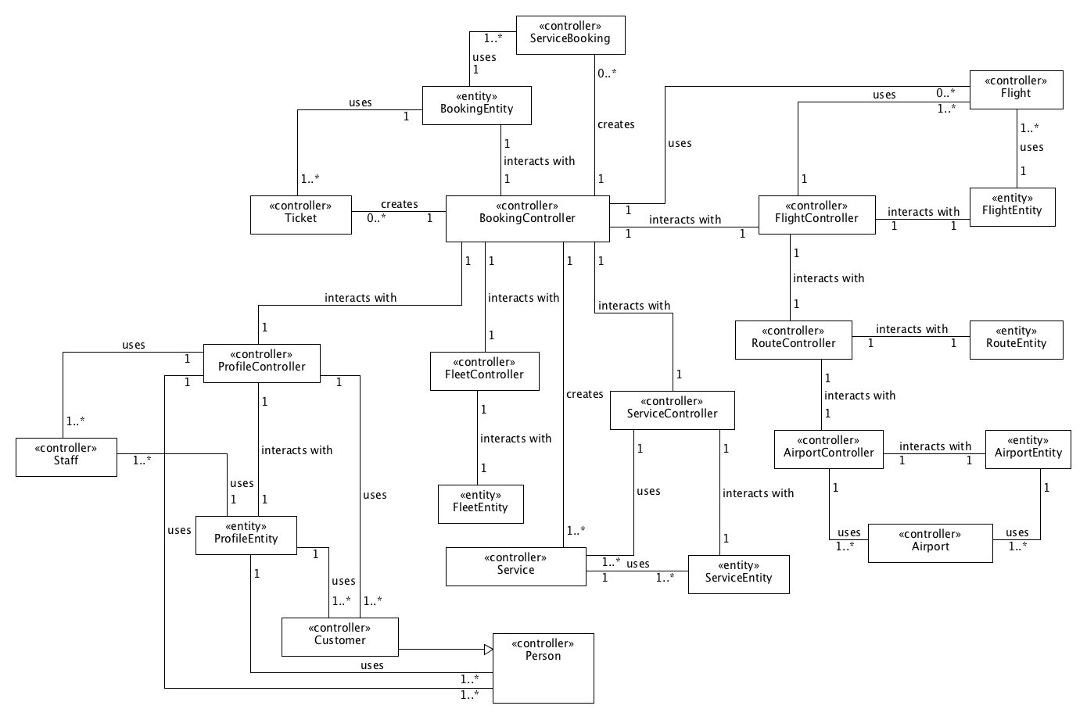

2. Class diagram showing the classes involved in the reporting subsystem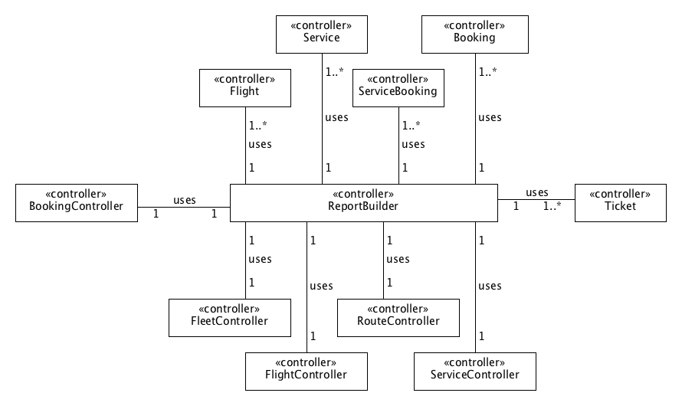

3. Class diagram showing the classes that represent the various roles within the system.

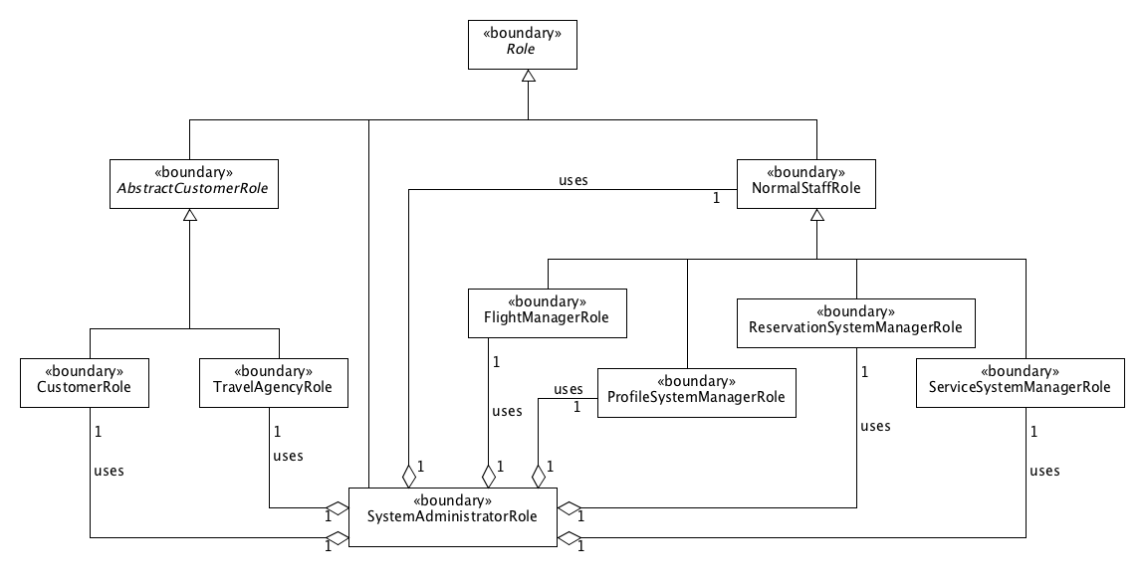

4. Class diagram that show the interaction between the role classes and the controller classes.

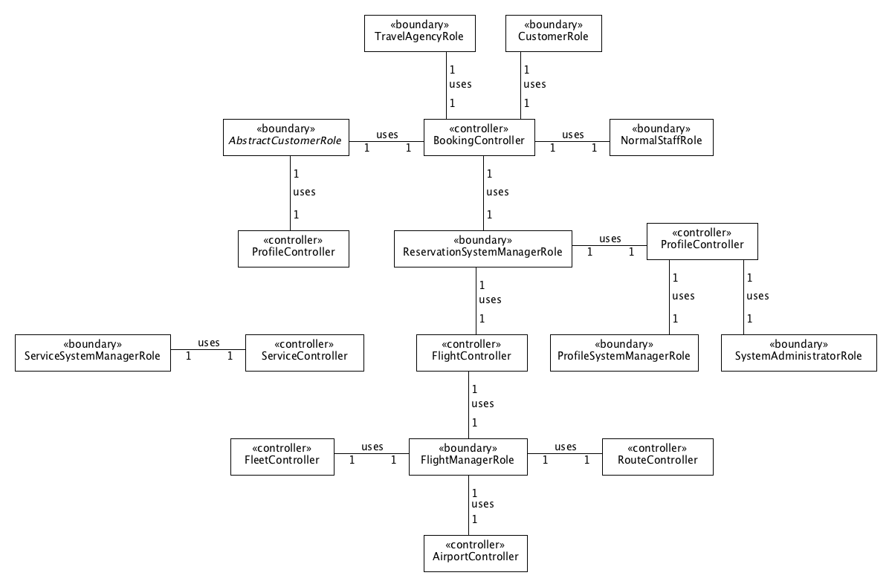

5. Class diagram that shows the skeleton of the system. Login, signup, logout and role delegation functionality are done here.

